**LAB – 3**

Name: Gandevia Keval Dharmeshbhai

Sem: VII

Roll No: CE046

Subject: Image Processing

**Q. 1: Calculate the brightness and contrast of the images.**

* **High brightness image**
* 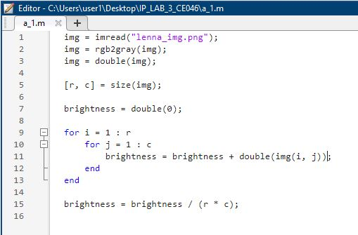Code:
* 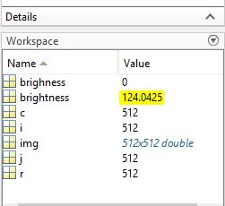Output:
* **Low brightness image**
* 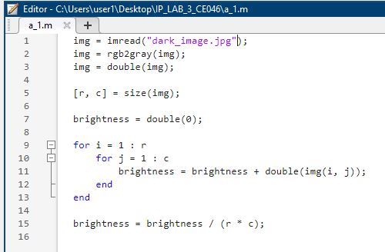Code:
* 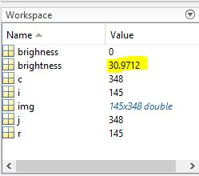Output:
* **High contrast image**
* 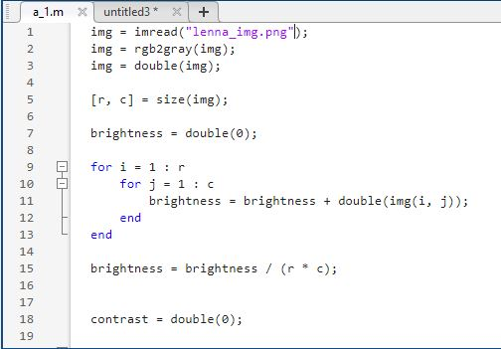Code:

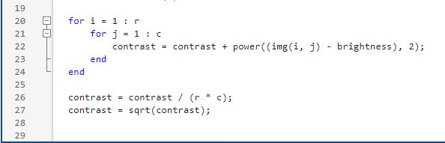

* 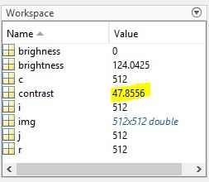Output:
* **Low contrast image**
* Code:

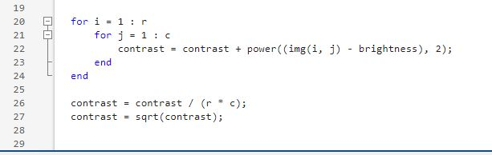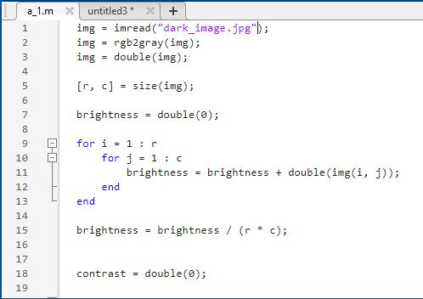

* 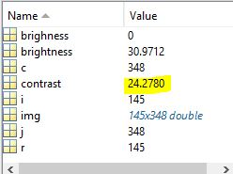Output:

**Q. 2: Perform AND, NOT, and OR logical operations on the images.**

* **Logical AND**
* 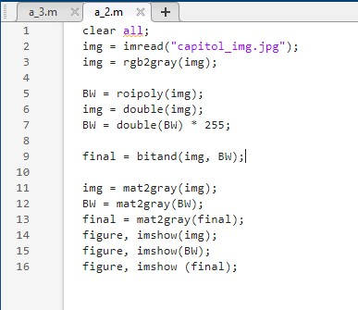Code:
* Output:

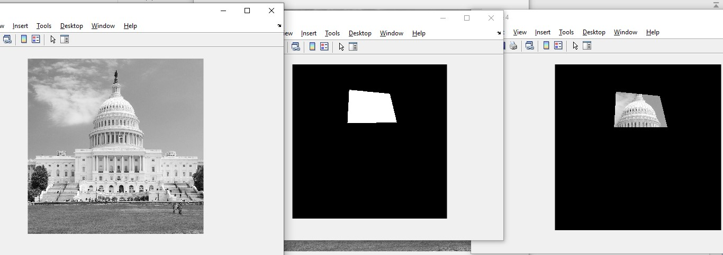

* **Logical NOT**
* 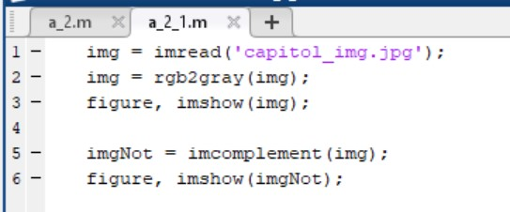Code:
* 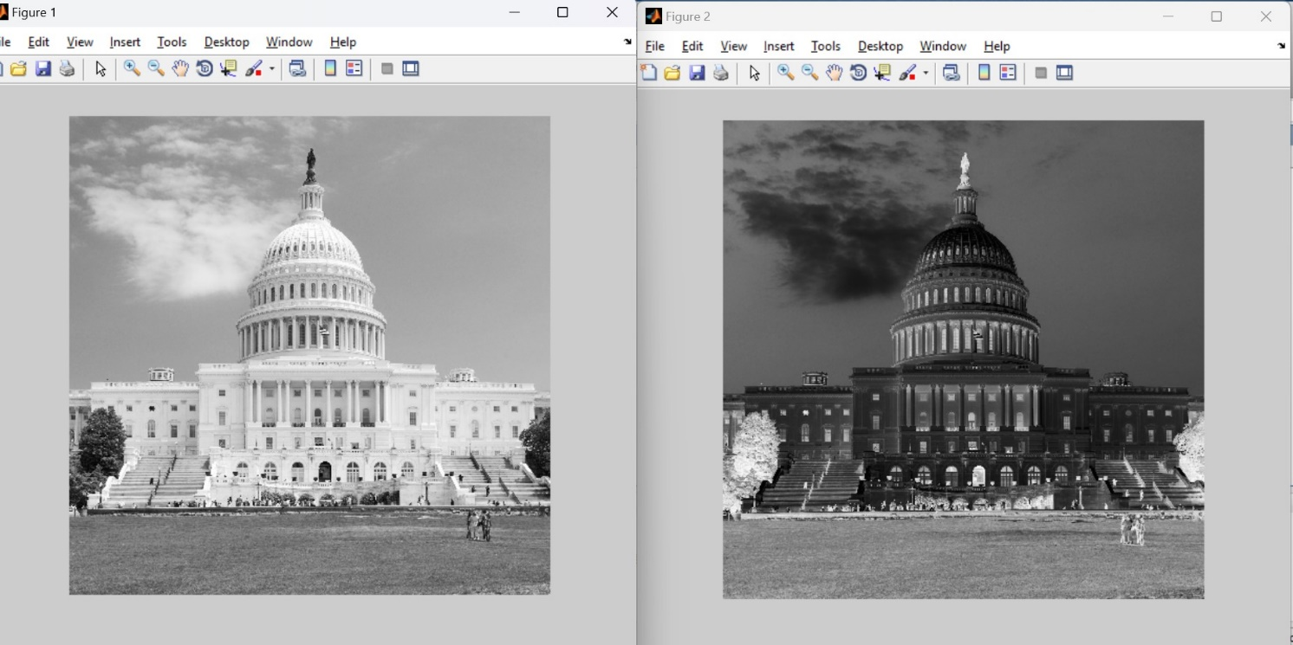Output:
* **Logical OR**
* 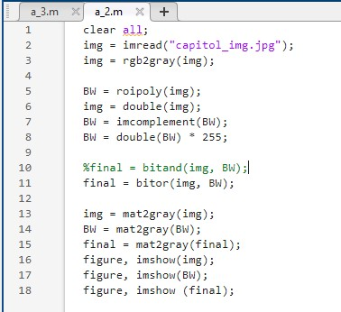Code:
* 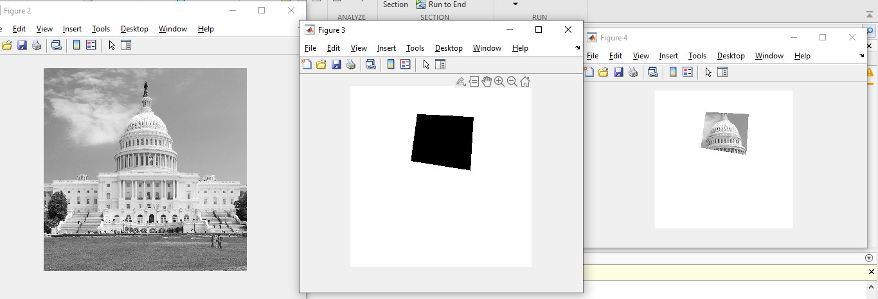Output:

**Q. 3: Perform image shrinking operation on the image.**

* 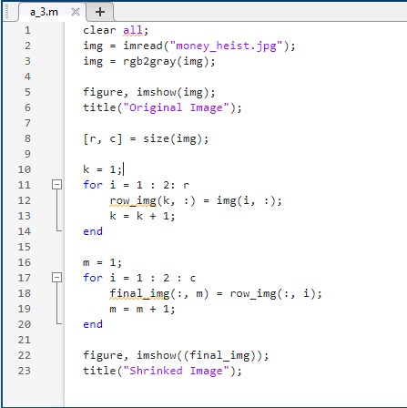Code:
* 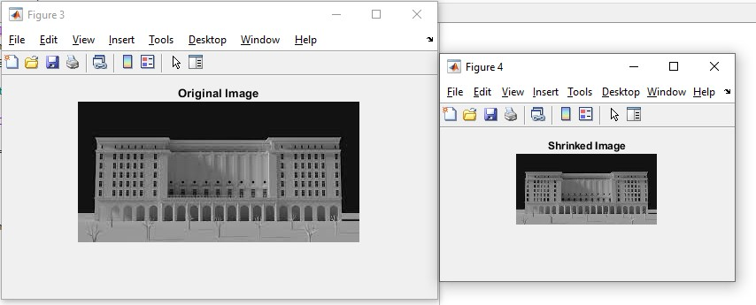Output:

**Q. 4: Perform image transformation. (Rotation)**

* **Using rot90() function**
* 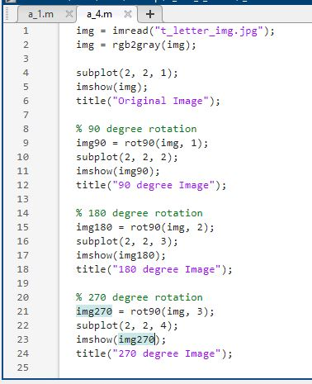Code:
* Output:

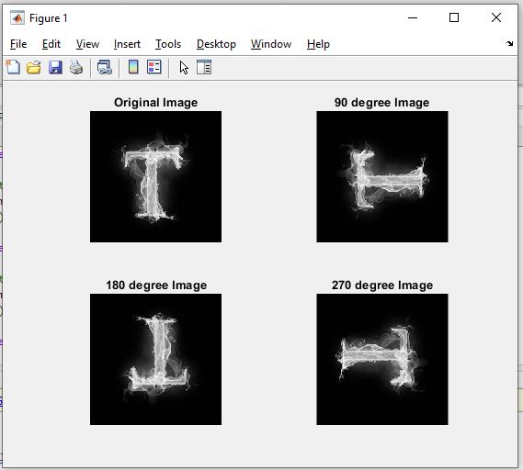

* **Using imrotate() function**
* Code:

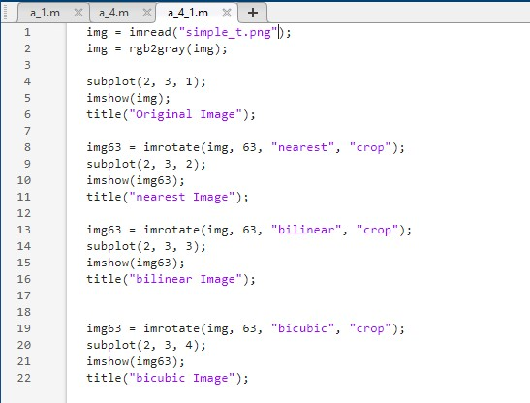

* 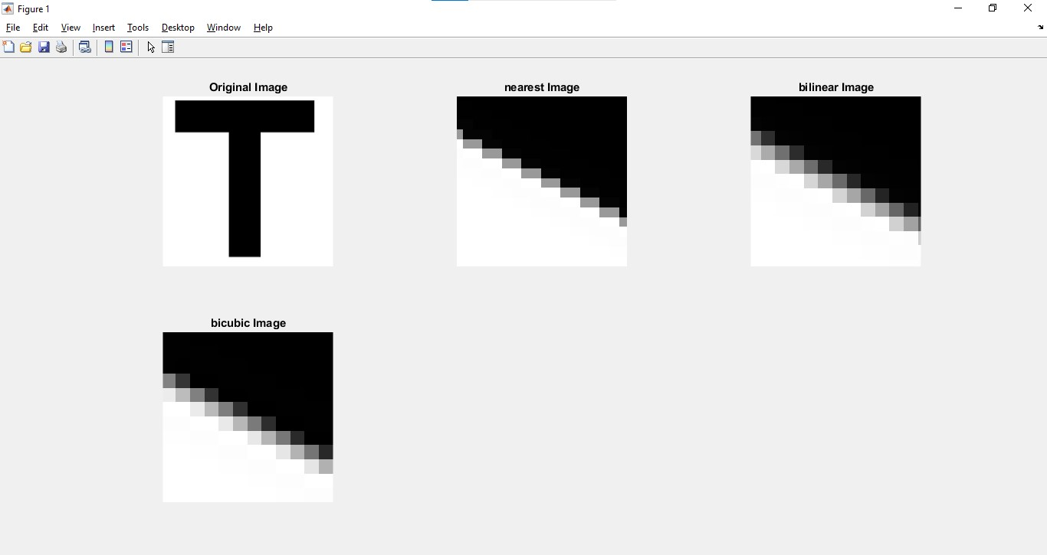Output: